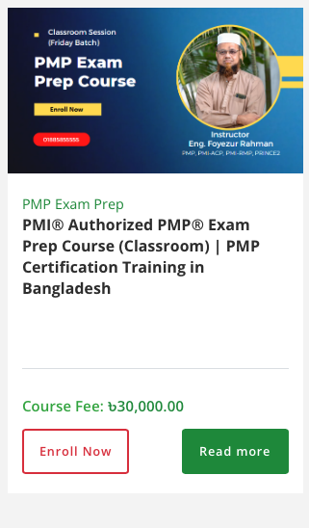
Course create:
Title
Sub-title
Course fee
Course Image
Promo video link (Youtube embed link)
Course overview: (long Text field with editor)
Course Content: (long Text field with editor)
Instructor Name: (Should be multiple and dropdown selected from database)
Course Schedule
Enroll Now / Registration link: (google form)
Brochure: for download in pdf
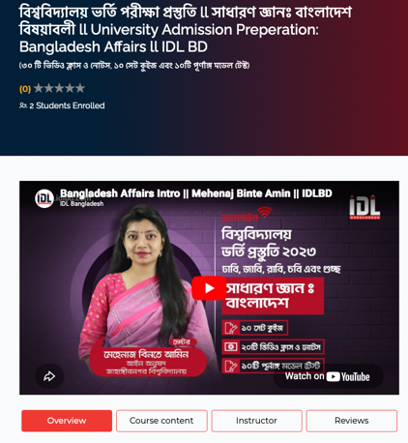

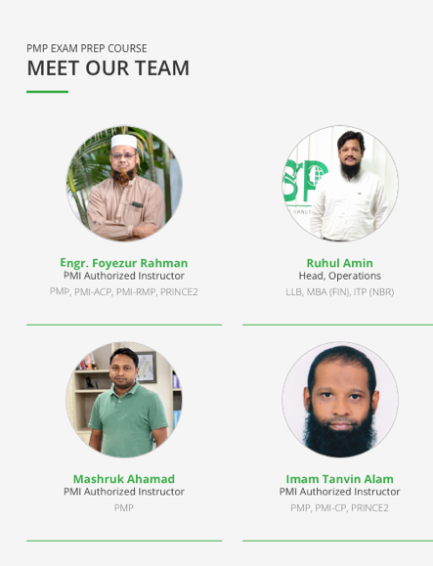
Instructor Pool:
Name
Designation
Image
Qualifications
Bio: (long Text field with editor)

Testimonial: (Image, Name, designation, ,
Name
Designation
Image
Comments
Social link

Valued clients: (name and logo)

